RESULTS

CALCULATING METRICS

M1 – M2: Embedding Time and Index Size
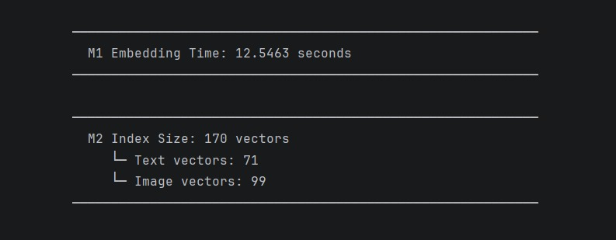
Figure 1: Embedding Time and Index Size Output

M3 – M5: Retrieval Metrics
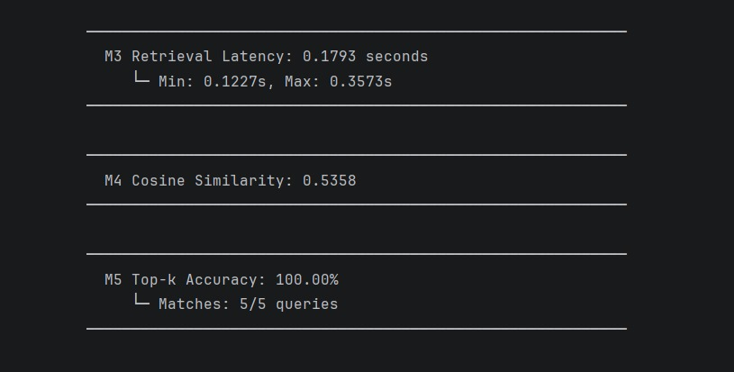
Figure 2: Retrieval Quality Metrics Output

M6 – M8 & M15: Generation Metrics
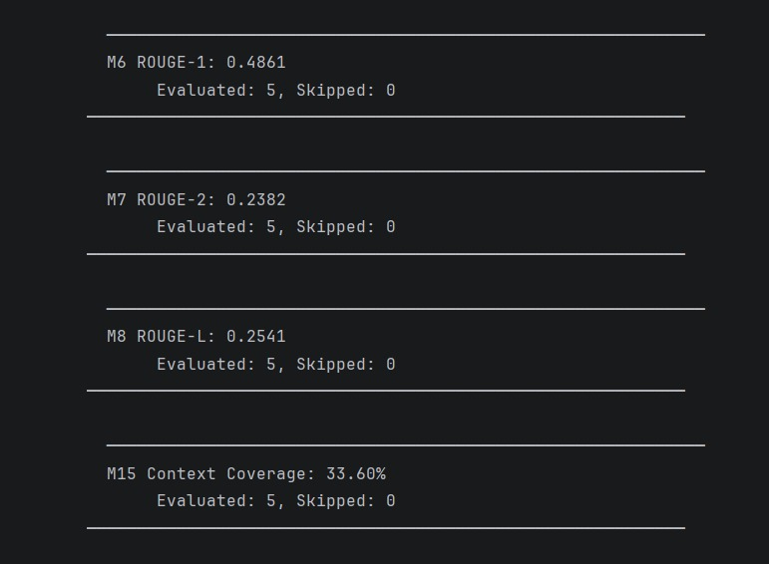
Figure 3: Generation Quality Metrics Output

M9 – M19: Context & System Performance Metrics
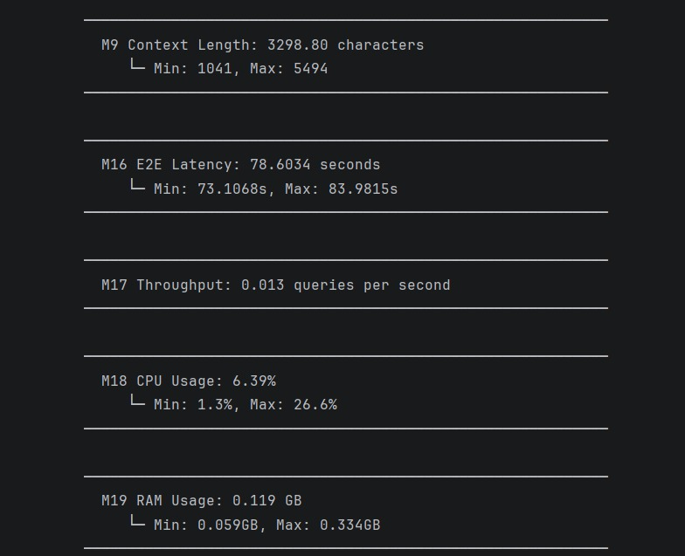
Figure 4: System Performance Metrics Output

FINAL METRICS SUMMARY

Embedding Statistics
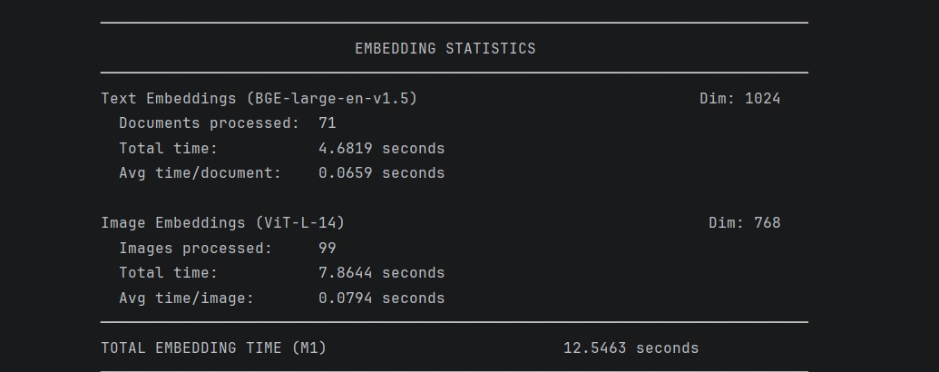
Figure 5: Embedding Statistics Summary

Final Metrics Table
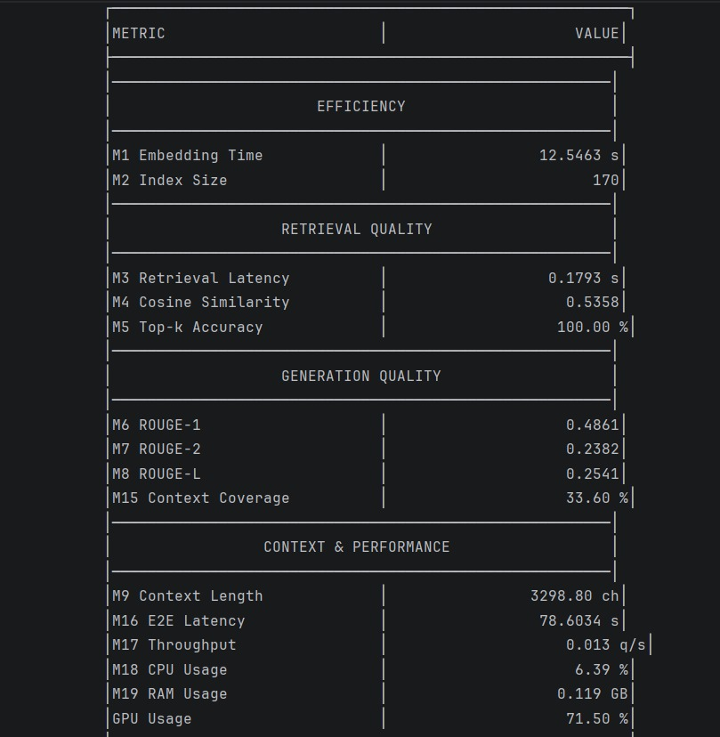
Figure 6: Final Metrics Summary Table

